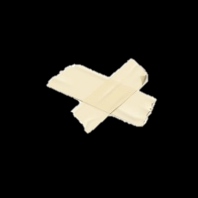

Subject expertise to raise expectations of wat is possible and how excellence can be developed, built upon and progress

Are you willing to make the activity part of a broader community engagement piece?

Content and how it can be used for future projects

Access to schools, to promote half term programmes, promoting outside of school’s art club program

Communication with Head Teacher

Show how project meets school priorities

Valuing the process rather than always outcome/ product focused

Purposeful, honest, explorative, conversation to determine projects for school communities

Understanding value of artists, that we have to pay our bills and it’s our job, as well as love and passion

Do I need experience?

The confidence to help provide transferable skills of links to the curriculum beyond the Arts, (eg; solving problems and talking through views helps)

Enough time with the children (or equivalent and relevant to outcomes)

Important to be open to conversations that are meaningful

Thinking of the importance for all children without bias of “arts”

It’s important to have a deadline and an idea about the final outcome but flexibility on what the final outcome will look like it essential to the creative process.

Show meaningful value to students i.e.; tangible outcome

Shared vision of process vs product

To know clearly what outcome the school wants, so to improvise and make sure my tailored art project has that of a focal point.

Trying to understand schools perspective