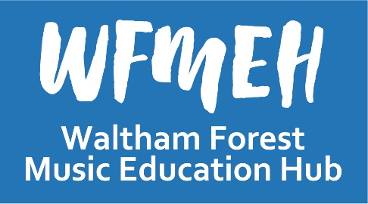
Curriculum Guidance for Schools:
School Music Education Plans

This document is intended for Headteachers, Senior Leadership Teams, and Music Leaders, and contains information and guidance for schools about:

• The new Ofsted Inspection Framework
• Writing a School Music Policy or Education Plan

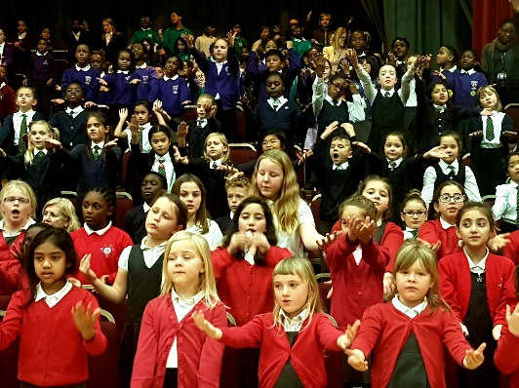
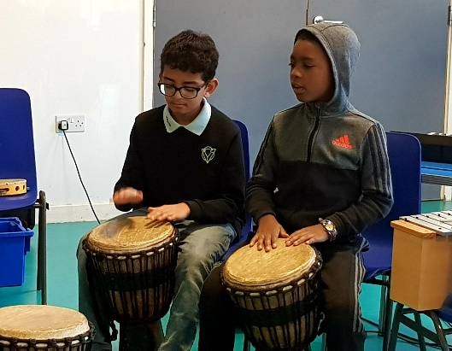
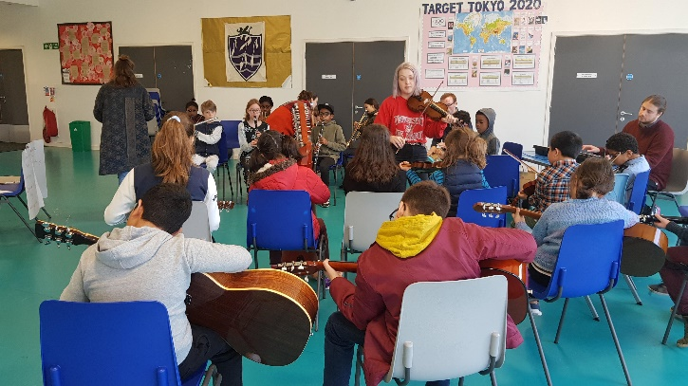

Waltham Forest Music Education Hub
The School Lodge, Woodbury Road E17 9SB
020 8496 1584
music.service@walthamforest.gov.uk
Introduction
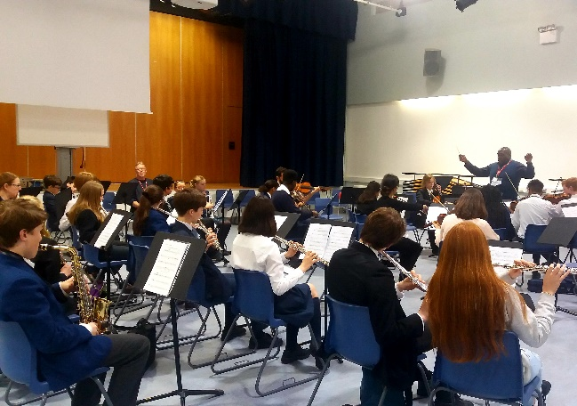
Music Education Hubs in England are a resource to help support all schools in their local area. The Waltham Forest Music Education Hub (WFMEH) aims to have an active and positive relationship with every school in Waltham Forest.
Music Education Hubs have been tasked with ensuring that all schools have a School Music Education Plan (SMEP). In essence, this is focused on schools identifying how they deliver music in their curriculum and how they engage a range of additional support to help realise their school vision.
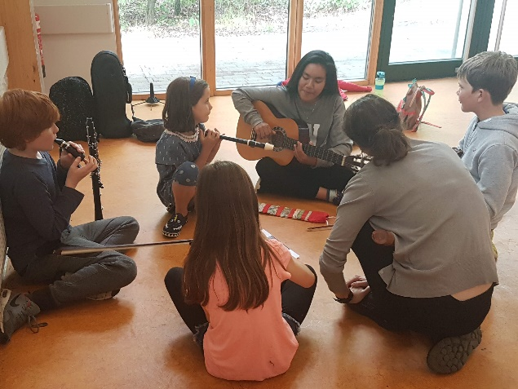
A School Music Education Plan (SMEP) should not be complicated but needs to indicate that schools are delivering a Music Curriculum and ensuring that pupils have the opportunity to learn to play an instrument, sing regularly, to perform and hear live music, and to work with professional musicians.
In order to support schools, the WFMEH has adopted this guidance from the Tri-borough Music Hub which outlines the revised Education Inspection Framework from Ofsted and gives suggestions for generating a simple school music policy or ‘SMEP’.
It is recommended that all schools use this guidance to feed into their own school development plan. This can be discussed with WFMEH colleagues and could be used to determine future priorities. It will also provide valuable information to the WFMEH who can then provide support as appropriate.

Ofsted Framework and Handbook for inspection
The new Education Inspection Framework (EIF) and handbook from Ofsted (link HERE) has been in use from September 2019. This section highlights areas which might support good music education in all schools.
The current framework has offered a degree of accountability with the broader curriculum for schools, for example with references in Ofsted reports to schools achieving the Arts Mark. This is an evolution not revolution. There will be a much greater emphasis on the curriculum in the EIF. The concentration on the curriculum has been flagged up previously.

1.Paragraph 14
“in a risk assessment, we analyse: school workforce census data” This will contain each secondary school’s report on the number of hours of teaching provided in each school year for each subject. Schools that are not offering any music may be flagged up in this process.
Questions to consider:
➢ Who is delivering your music curriculum lessons?
- Are they appropriately qualified?
- How are they supported in accessing appropriate music-specific professional development?
➢ How are these lessons structured?
- Are music curriculum lessons timetabled to allow progressive development of learning skills and knowledge through weekly teaching?
- If adopting a carousel approach, how is this developing skills and knowledge on a progressive basis?
➢ Would the School Music Policy (see p.10) help identify how music is being delivered, and areas to develop?

2.Paragraph 22
In addition, exempt schools may be inspected between risk assessments if:
- Ofsted have received a qualifying complaint that, taken alongside other available evidence, suggests that they should inspect the school
- Concerns are identified about the curriculum (including if the statutory requirement to publish information to parents is not met)
- Ofsted inspectors will receive information about qualifying complaints, it is not currently clear if lack of access to a curriculum subject is considered to be a qualifying complaint. Other complaints may be noted by the team as well as those pertaining to safeguarding.
Questions to consider:
➢ Is the school curriculum genuinely broad and balanced to reflect the needs of all learners, including pupils with SEND (i.e. in accessing a range of arts subjects)?
➢ Would the School Music Policy (see p.9 help identify how music is being delivered, and areas to develop?

3. Paragraph 44
OFSTED will: - report on any failure to comply with statutory requirements when they form part of the inspection framework and evaluation schedule, including those relating to the workforce. It is not clear if or how this might identify schools failing to meet statutory requirements in relation to curriculum subjects. However, several non-core curriculum areas will be subject to the process of a “deep dive.” This could include music.
Questions to consider:
➢ If pressed by an inspector, are you able to talk about how your curriculum is sequenced to allow progressive development of learning skills and knowledge through weekly teaching?
➢ Can you provide pupil information for music/arts subjects to demonstrate impact?
➢ Do your Schemes of Work appropriately reflect learning needs of your pupils, to allow engaged learning to take place?
➢ Does your school assessment process allow flexibility for arts subjects to reflect assessment/progress in different ways?

4. Paragraph 166
“Before making the final judgement on overall effectiveness, inspectors will always consider the spiritual, moral, social and cultural development of pupils at the school, and evaluate the extent to which the school’s education provision meets different pupils’ needs, including pupils with SEND.” Attention to spiritual, moral, social and cultural development in the current framework for inspection has often led to mention of good practice in relation to music and the Arts in inspection reports.
The new framework specifically mentions:
- sense of enjoyment and fascination in learning about themselves, others and the world around them (para 217)
- use of imagination and creativity in their learning (para 217)
- willingness to reflect on their experiences. (para 217)
- use of a range of social skills in different contexts, for example working and socialising with other pupils, including those from different religious, ethnic and socio-economic backgrounds (para219)
- interest in exploring, improving understanding of and showing respect for different faiths and cultural diversity and the extent to which they understand, accept, respect and celebrate diversity. This is shown by their respect and attitudes towards different religious, ethnic and socio-economic groups in the local, national and global communities. (paragraph 219)
- willingness to participate in and respond positively to artistic, musical, sporting and cultural opportunities (para 220)
Questions to consider:
➢ Are pupils able to express themselves through arts/music both in the curriculum, and through programmed extra-curricular activities?
➢ Is there a weekly singing opportunity for all pupils (e.g. through collective worship)?
➢ Are your pupils allowed to leave curriculum lessons to attend instrumental/vocal lessons, or to attend school ensemble rehearsals?
➢ Are pupils taken to a range of external interactive live artistic activities/performances to broaden their exposure to a range of opportunities?
➢ Are your music teachers given opportunities to attend external CPD events that will result in a broad range of benefits for pupils?

5. Paragraph 172
“All pupils in maintained schools are expected to study the basic curriculum, which includes national curriculum, religious education and age-appropriate relationship and sex education. Academies are expected to offer all pupils a broad curriculum that should be similar in breath and ambition.” Although not specified in this paragraph there is also a duty on schools regarding fundamental British values and collective worship. Music is part of the national curriculum and should be taught to all pupils until the end of KS3.
Questions to consider:
➢ Is there a weekly singing opportunity for all pupils (e.g. through collective worship)?
➢ How is your school proactively using music/arts subjects to promote fundamental British values, and to engage all learners?
➢ How is your school using music/arts subjects to engage parents/carers and the wider community?

6. Paragraph 173
“We will judge schools taking radically different approaches to the curriculum fairly. We recognise the importance of schools’ autonomy to choose their own curriculum approaches. If leaders are able to show that they have thought carefully, that they have built a curriculum with appropriate coverage, content, structure and sequencing, and that it has been implemented effectively, then inspectors will assess a school’s curriculum favourably.” Some have expressed concern about this paragraph because they believe it might provide a means of explaining away the lack of a rigorous and comprehensive Arts curriculum. It is difficult to see however, how a curriculum could be said to have ‘appropriate coverage and content’ if a subject which is so unequivocally a requirement for cultural capital were missing.
Questions to consider:
➢ Do your Schemes of Work appropriately reflect learning needs of your pupils, to allow engaged learning to take place?
➢ Is your school able to talk about how your curriculum is sequenced to allow progressive development of learning skills and knowledge through weekly teaching?
➢ Does your school assessment process allow flexibility for arts subjects to reflect assessment/progress in different ways?
➢ Has your school music teacher(s) been supported in accessing peer development with music teachers in other schools to help support and quality assure a secure curriculum?
➢ Are your music teachers given opportunities to attend external CPD events that will result in a broad range of benefits for pupils?
7. Paragraph 176
As part of making the judgement about the quality of education, inspectors will consider the extent to which schools are equipping pupils with the knowledge and cultural capital they need to succeed in life. Our understanding of ‘knowledge and cultural capital’ is derived from the following wording in the national curriculum: ‘It is the essential knowledge that pupils need to be educated citizens, introducing them to the best that has been thought and said and helping to engender an appreciation of human creativity and achievement.’
Questions to consider:
➢ Are pupils able to positively articulate their experiences of music/arts subjects that they are exposed to through their school life?
➢ Are pupils actively encouraged to engage with music/arts subjects as part of healthy balanced approach to learning?
➢ Are pupils able to express themselves through arts/music both in the curriculum, and through programmed extra-curricular activities?
➢ Are pupils taken to a range of external interactive live artistic activities/performances to broaden their exposure to a range of opportunities?

8. Paragraph 180 -181
Implementation: 180. In evaluating the implementation of the curriculum, inspectors will primarily evaluate how the curriculum is taught at subject and classroom level. 181. Research and inspection evidence suggest that the most important factors in how, and how effectively, the curriculum is taught and assessed are that: - Teachers have expert knowledge of the subjects that they teach. If they do not, they are supported to address gaps in their knowledge so that pupils are not disadvantaged by ineffective teaching.
Inspection reports based on the current Ofsted Framework frequently mention the detrimental impact of teachers’ poor subject knowledge on the quality of certain subjects. This is more frequently mentioned in reports on primary schools. The text in this paragraph of the new handbook is much clearer about expectations on schools. It also highlights the need to employ teachers with proper knowledge of the curriculum, carefully planned schemes or sufficient CPD in subject areas.
Questions to consider:
➢ Who is delivering your music curriculum lessons?
- Are they appropriately qualified?
- How are they supported in accessing appropriate music-specific professional development?
➢ Are your music teachers given opportunities to attend external CPD events that will result in improved learning?
➢ Do your Schemes of Work appropriately reflect learning needs of your pupils, to allow engaged learning to take place?
➢ Does your school assessment process allow flexibility for arts subjects to reflect assessment/progress in different ways?
➢ Has your school music teacher been supported in accessing peer development with music teachers in other schools to help support and quality assure a secure curriculum?

9. Paragraph 223
Sources of evidence specific to personal development. Inspectors will use a range of evidence to evaluate personal development, including: - how curriculum subjects such as citizenship, RE, and other areas such as personal, social, health and economic education, and relationship and sex education, contribute to pupils’ personal development.
Questions to consider:
➢ Are pupils able to positively articulate their experiences of music/arts subjects that they are exposed to through their school life?
➢ Are pupils actively encouraged to engage with music/arts subjects as part of healthy balanced approach to learning and their personal development?
➢ Are pupils able to express themselves through arts/music both in the curriculum, and through programmed extra-curricular activities?
➢ Are pupils taken to a range of external interactive live artistic activities/performances to broaden their exposure to a range of opportunities?

Writing a School Music Policy or Education Plan
By using the prompts below schools/settings will achieve an overview of their delivery of music education & have an effective School Music Policy.
A Music Policy/SMEP for an EYFS setting should include:

a) Who is responsible for leading the music provision in your setting?
b) What is the rationale for delivery of music across the setting? (music is important for the holistic development of children)
c) How is music included in the planning?
d) How musically rich environments are created in your setting, e.g. are instruments/music making resources readily available?
e) What the provision is for singing, music listening, moving and dancing, how often is this offered/catered for?
f) A clear policy regarding inappropriate/appropriate use of recorded music with consideration of lyrical content
g) Details of external music organisations/people that regularly work in the setting
h) How often there are performances in the setting? Are children are taken to performances?
i) How children’s music making is valued, documented and shared

A Music Policy/SMEP for a Primary Phase school (5-11) should include:

a) Who teaches the weekly Curriculum Music lessons
b) How music is timetabled weekly
c) How musical progression is assessed
d) What the provision for singing is [is there a regular weekly whole school (or phase) singing opportunity? is there a school choir? is there a regular accessible music opportunity (in relation to SEND)?]
e) What instrumental opportunities and/or extra-curricular learning is available. What are these opportunities and when do they happen?
f) Which external music organisations regularly work in school (who are the organisations and what is their remit in the school?)
g) Who the assigned music co-ordinator is
h) How often there are performances in the setting? Are children are taken to performances?
i) How children’s music making is valued, documented and shared
j) How the school links with the Music Education Hub
k) How often there are performances in the school
l) How music is used in cross-curricular work
m) How inclusive your music provision is; and how you cater for all children’s needs*
n) How technology is used to aid musical learning

A Music Policy/SMEP for a Secondary Phase and Post-16 Phase school (11-18) should include:

a) How music is delivered across KS3 and how musical progression is assessed
b) How KS3 provision builds upon KS2 prior attainment and accounts for transition between Key Stages
c) Who the assigned lead for music in the school is
d) The provision on offer post KS3 (e.g. GCSE/BTEC or other). If so, which course and which Exam board? How many students are taking the exams in each year?
e) What your staffing for class music is; and what the roles of staff are
f) How a regular weekly school choir is delivered
g) How regular and/or extra-curricular weekly ensembles are delivered
h) What instrumental learning opportunities are available; what these are; and how they link to progressive, developmental and sustainable work
i) Which external music organisations regularly work in school (who are the organisations & what is their remit in the school?)
j) How the school links with the Music Education Hub
k) How often there are performances in school
l) How music is used in cross-curricular work
m) How technology is used to aid musical learning
n) How inclusive your music provision is; and how you cater for all children’s needs*

Further considerations for work with SEND and in SEND settings (*):

- We know that engagement is central to inclusive practice, therefore how do you support & facilitate this in your setting?
- Do you use any specific techniques, or pedagogical approaches? If so, what are these? And how do they support children accessing a meaningful and appropriate curriculum? For instance, do you make provision for music therapy? Does your provision consider the sensory/experiential role of music in a SEND setting? Music & SEND specific CPD?
- Does your setting working collaboratively with other Schools/SEND schools to support provision?
- Research and the sharing of best practice helps to support young people’s experience and access to high quality music education. Do you belong to any networks or carry out any research in your setting?

The information above is not an exhaustive list, and there will be many other ways you incorporate a range of arts and cultural experiences in your curriculum. If you would like to discuss any aspect of your music education needs with us please do get in touch with mary.mycroft@walthamforest.gov.uk .

