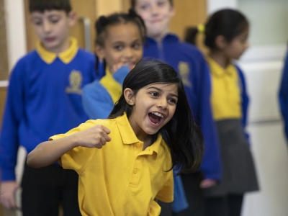
Case Study - Matt Hanks, Headteacher, Roger Ascham Primary School
Highlights from the school’s experience of working alongside Matthew Bourne’s New Adventures company for their whole school production of The Nutcracker for London Borough of Culture 2019.

Watch a 5 minute film about the project here

- Project involved two dancers/choreographers from New Adventures visiting the school - Gavin and Michaela. Both were trained ballet dancers and work all around the world (Michaela had to leave for a couple of days because she had to fly to Russia to perform for the Moscow Ballet but lives in Dalston so very comfortable working in East London as well).

- Roger Ascham School was designed in 1928. The classrooms are spaces where 30 children can just about fit. Junior hall barely fits all juniors – productions have to be done in shifts. For this whole school performance therefore Waltham forest lent the school the Walthamstow Assembly Hall. New Adventures extended the stage and made it look like a professional gig.

- The final show was packed and afterwards the children said things like, “oh yeah. I was in the ballet, I was in the Nutcracker, yeah- Matthew Bourne, I did that.”

- Experience will stay with them. Some of the older children worked with the younger ones, so each nursery, reception, infant class had groups of junior children, the older ones, working with them, dancing alongside them.

- Project helped children think outside the box and supported their learning in other areas like maths and English.

- The legacy is that the work has continued on a small scale in a sustainable relationship. The partnership with New Adventures is established and school now spending a little bit of money having a small performance space put into the hall.

- Two dancers now regularly visit from New Adventures and from Sadlers Wells (Roger Ascham is one of Sadlers’ partnerships schools in East London because they’re building a new theatre in Stratford)

- The current project theme is a 1930s beach scene. The dancers do not tell the children what the movement is, they develop their own that matches the vocabulary which will include new words like ‘surge’ for this project. The dancers teach them precision and poise, and how to deliver their own ideas for maximum impact. The dancers then get the children to pick 4 of the movements and put them together to move from one place to another. The children are therefore being totally creative and are applying this approach to other areas of the curriculum.

- The children are also learning to work together and have a great time in the process.

