ESFA
Education and Skills Funding Agency

Ebacc
English Baccalaureate: GCSE qualification in English, Maths, Science, Humanities and Modern Foreign Language. Secondary schools are measured on the number of pupils that take GCSEs in these core subjects. Schools are also measured on how well their pupils do in these subjects.

CEP
Cultural Education Partnership
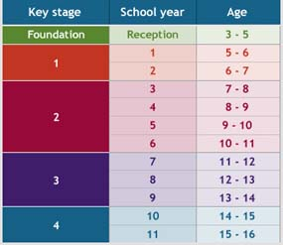
Keystage e.g. KS3
A Key Stage is a stage of the state education system.

Safeguarding
Safeguarding is protecting the health, well-being and human rights of individuals, which allow people - especially children, young people and vulnerable adults - to live free from abuse, harm and neglect.

DBS
Disclosure and Barring Service: formally known as CRB (Criminal Records Bureau). A DBS needs to be renewed every 3 years in order for it to be considered ‘up to date’.

Progress 8
A measure of student progress, relative to the national average, in order to measure the effectiveness of secondary schools.

PP
Pupil Premium: additional funding for publicly funded schools in England. It's designed to help disadvantaged pupils of all abilities perform better, and close the gap between them and their peers.

FSM
Free School Meals

SIP
School Improvement Plan

Ofsted
Ofsted is the Office for Standards in Education, Children’s Services and Skills. They inspect and regulate services that care for children and young people, and services providing education and skills for learners of all ages.

Academies
Schools funded by the Education Funding Agency rather than by the Local Authority.

Free Schools
A free school is a non-profit-making, independent, state-funded school which is free to attend but which is not wholly controlled by a local authority, meaning that they have greater control over how they operate.

MAT
Multi-Academy Trust e.g. Harris Academies have almost 50 schools across London.

Enrichment Days
Enrichment Days take place throughout the academic year. They provide an opportunity to engage students in a range of activities that do not easily fit into the regular timetable, including theme days, visits, sports tournaments and catch-up classes.

Drop-Down Day
The usual time-table is suspended and replaced with a specific focus and/or theme.

SATs
Standard Assessment Tests: national curriculum tests for English and Maths at primary schools. These are taken at the end of KS1 (Year 2) and the end of KS2 (Year 6).

SMSC
Spiritual, moral, social and cultural development: all schools in England must show how well their pupils develop in SMSC.

